Scenario: check windowhandles
Step: Launch "WindowHandlePage" WebPage - PASS
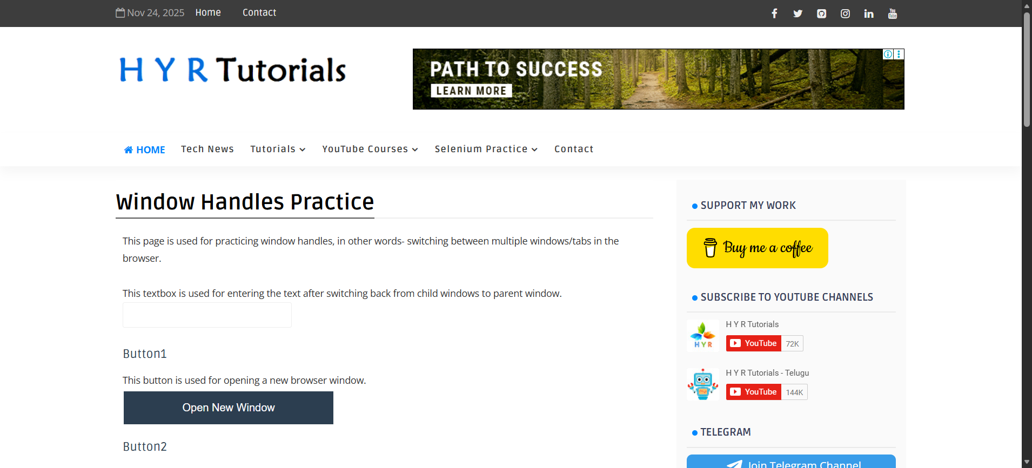
Step: User click the "Window_Button" element at "WHPage" page - PASS
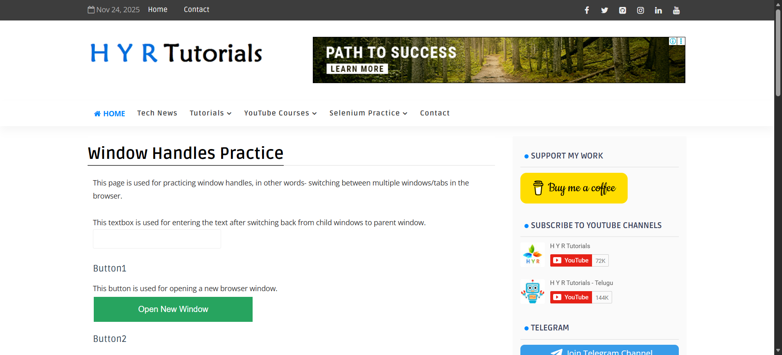
Execution Summary:
Total Steps: 2
Passed: 2
Failed: 0

